Student worksheet answers

2.1 Darwin and Wallace were co-conspirators
Pages 40–43

Evolutionary theory
1 What is relative dating?
Dating a fossil based on the layer of rock in which it was found. The rock layers represent different time periods.
2 Match the scientists with the correct contribution they gave to evolutionary theory:
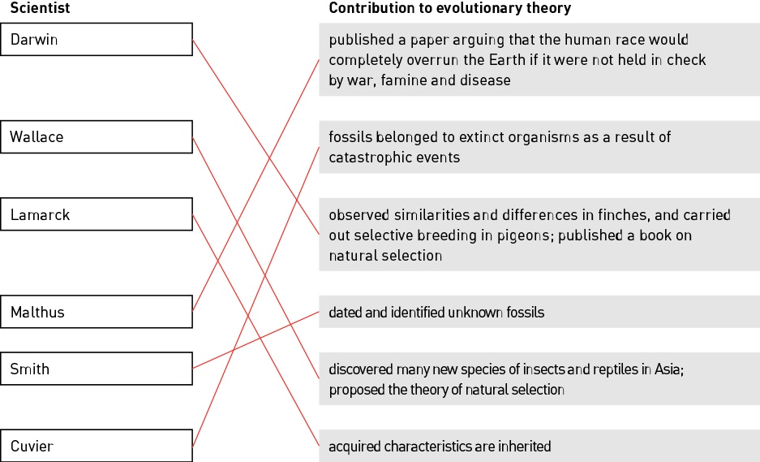
3 Using an example (other than giraffes), outline Lamarck’s theory of evolution.
Answers will vary. Any example could be used to describe how a phenotypic change during the lifetime of an organism is passed on to offspring in Lamarck’s theory. For example, if a person has a scar, their offspring will be born with a scar.
4 Describe the experiment Wiseman used to disproved Lamarck’s theory.
Wiseman cut the tails off mice and bred them over 22 generations. The offspring were still born with tails, unlike their tailless parents. If Lamarck’s theory was correct, the offspring would also be tailless.
5 Explain what is meant by ‘reproducible experimental evidence’. Include an example in your explanation.
Evidence produced from experiments that backs up scientific theory and can be repeated to produce the same findings/results/conclusions. Examples will vary.
6 Give an example of an organism that has been selectively bred by humans.
Answers will vary. For example, racehorses.
7 Explain how selective breeding leads to domestication of a species.
Humans select organisms to breed in an effort to ‘select’ for certain traits in their offspring. Over many generations, the ‘wild’ traits are often lost and the species is considered ‘domesticated’.

Extend your understanding
The two types of tortoises Darwin observed on the Galapagos Islands have either large, round shells (domed shells) or small, curved shells (saddleback shells).
8 In the following table, suggest a possible food each tortoise would eat and explain the advantage of having this shell type in terms of obtaining food.
 | Domed-shell tortoise | Saddleback-shell tortoise
Photo of tortoise showing shell shape | 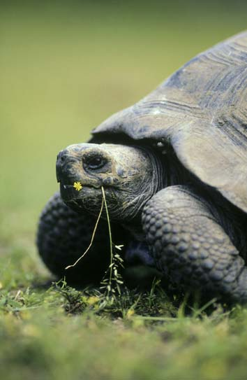 | 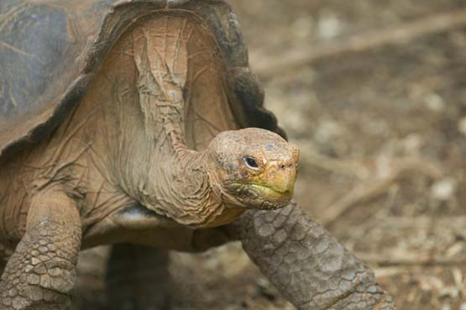
Possible food | Grass, pasture, low-lying dense vegetation | Shrubs, cactus, small trees
Advantage of shell shape | The rounded dome shell allows the tortoise to push through dense, low-lying vegetation. | The saddleback shell curves upwards, enabling the tortoise to reach up and stretch their neck to reach high vegetation on dry, bare islands.
9 Suggest a possible conclusion that Lamarck may have made about saddleback-shell tortoises based on his theory of acquired evolution.
Lamarck may have concluded that the tortoises’ shells curved upwards as they stretched their necks to reach for their food sources high up. This acquired trait would be passed on to the offspring of these tortoises.

Student worksheet answers

2.2 Natural selection is the mechanism of evolution
Pages 44–45

Natural selection
1 Write your own definition for the term gene pool with regards to genes and alleles.
A gene pool is the genetic makeup of a population, including all the alleles present for every gene.
2 The following image shows a population of red-beetles on a tree trunk. Red-beetles have either red, orange or brown wing colour.
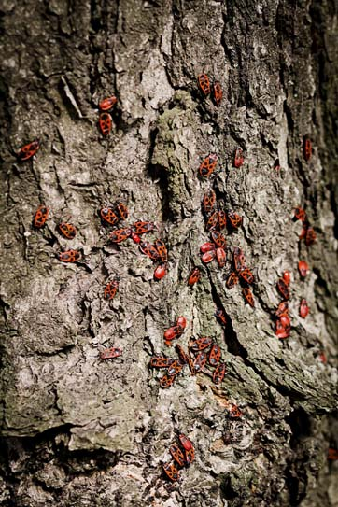
a Decide if each of the following descriptions is an observation or an inference.
i ‘Individual red-beetles that are most suited to their environment will survive.’
Inference
ii ‘There are red-beetle individuals with different wing colours.’
Observation
iii ‘Red-beetle parents will pass on their wing colour to their offspring.’
Inference
b Although the red-beetles within this population all have the same gene for wing colour, there is variation in wing colour between the red-beetles. Explain where this variation comes from.
Genetic differences between individuals are inherited. The gene for wing colour is expressed as different phenotypes due to individuals having different combinations of alleles that they have inherited. New phenotypes may also arise because of genetic mutations.
c Give ONE example of a possible selection pressure acting on this population of red-beetles.
Students answers will vary. Examples may include change in tree-trunk colouration, new predators, competition for a food source.
d A new predatory species of bird is now eating this species of red-beetles, as seen in the data in the following table.
changes in frequency of different coloured red-beetles over 12 months after the introduction of predatory birds
Time (months) | Red-winged  red-beetle | Orange-winged  red-beetle | Brown-winged  red-beetle
0 | 28 | 13 | 6
3 | 16 | 14 | 8
6 | 14 | 12 | 14
9 | 8 | 10 | 19
12 | 4 | 11 | 23
In the space below, draw a line graph showing changes in the frequency of red-, orange-, and brown-winged red-beetles over 12 months.

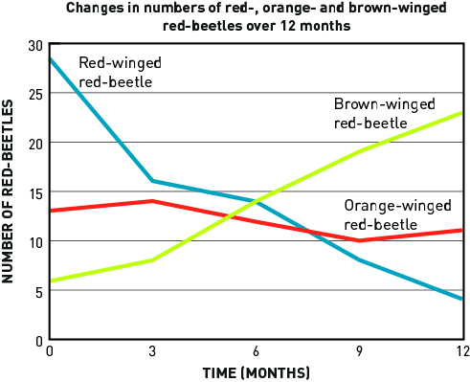
e Which phenotype is being selected against?
Red-winged
f Suggest why there was an increase in the number of brown-winged red-beetles within this population.
Brown colouration gives greater camouflage than red or orange colouration. This results in fewer brown beetles being eaten.
g In your own words, outline how the process of natural selection has altered the allele frequency for the wing-colour gene within the population of red-beetles over time.
Brown-winged beetles are being selected for, while red- and orange-winged beetles are being selected against (being eaten in greater frequency). Brown-winged beetles survive, reproduce, and pass on their alleles for brown wing colour to their offspring. In the next generation, there are greater number of brown-winged beetles and a greater frequency of the alleles that result in this phenotype.

Extend your understanding
3 Apply your understanding of natural selection to discuss how the use of antibiotics can result in directional selection and an increase in bacteria that are resistance to antibiotics over time.
Antibiotics kill bacteria that have no resistance. A few bacteria that have resistance to the antibiotic can survive and reproduce, passing their resistance to their offspring. As a result, all of the next generation will be resistant to that particular antibiotic. Consequently, if the antibiotic is used again, it will be ineffective.

Student worksheet answers

2.3 Different selection pressures cause divergence. Similar selection pressures cause convergence
Pages 46–47

Divergent and convergent evolution
1 Match each term with the correct example or description.
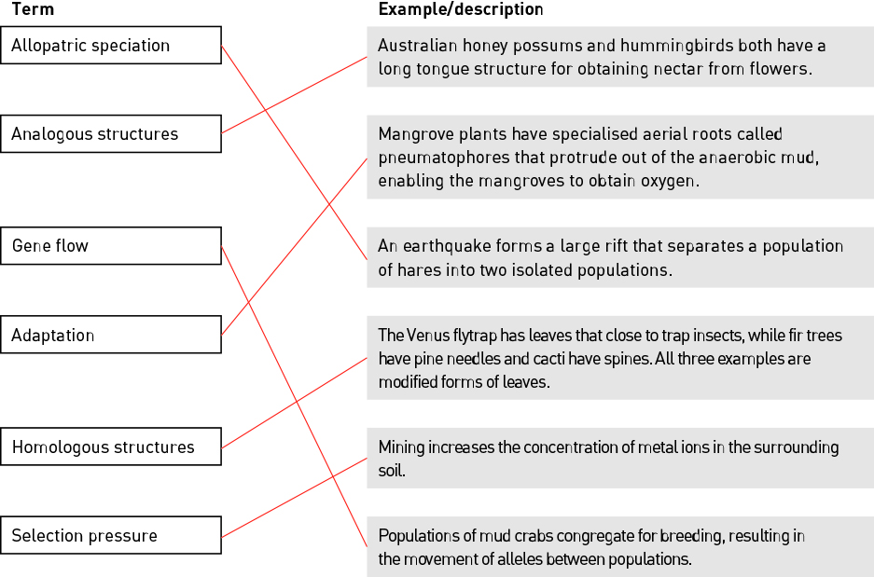
2 Explain why the wings of bats and birds are described as analogous structures yet their forelimbs are homologous structures.
The wings of bats and birds have evolved independently of each other after they last diverged from a common ancestor. They developed due to similar selection pressures in their environments to perform the same function (flight), however, the wings of bats and birds are structurally different. The forelimbs of bats and birds are structurally similar and were present when they both last shared a common ancestor.

3 Fill in the blanks to complete the paragraph below.
Within any population there is variation between individuals. A population is sometimes split into two and become isolated from each other. This means there is no gene flow. Each population is exposed to different selection pressures. This changes the allelic frequency within each population and they eventually become reproductively isolated and can no longer interbreed. Two different species are formed that have diverged during the process of allopatric speciation.
4 Describe the difference between natural selection and divergent evolution.
Natural selection is a process whereby individuals better suited to the environment survive and pass on their desirable traits to the next generation. Over time, different populations may be very different to each other due to different selection pressures acting on each population, resulting in speciation. This change over a long period of time can be described as divergent evolution.

Extend your understanding
5 In the space below, draw an annotated diagram outlining how different selection pressures result in divergence.
Student diagrams will vary.

Student worksheet answers

2.4 Fossils provide evidence of evolution
Pages 48–51

Fossil evidence
1 Complete the following table by writing the correct terms and definitions in the spaces provided.
Term | Definition
Fossil | Remains of organisms from a past geological age embedded in rocks or other substances by natural processes
Fossilisation | The process of an organism becoming a fossil
Transitional fossil | A fossil or an organism that shows the intermediate state between an ancestral form and that of its descendants; also known as a ‘missing link’
Absolute dating | A method that uses the amount of radioactivity remaining in the rock surrounding the fossil to determine its age
Living fossil | An existing species of ancient lineage that has remained unchanged in form for a very long time
Half-life | The time it takes for radioactivity to decrease by half
2 Use the image of a fossil to answer the following questions.
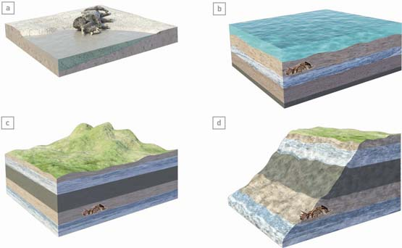
a Is this a relatively young fossil or a relatively old fossil?
Relatively old
b Name ONE process that will eventually expose this fossil.
Answers will vary. For example, weathering, erosion, mining
c Outline how relative dating could be used to determine the age of this fossil.
Most fossils are found in sedimentary rock, formed by layers of silt or mud on top of each other. Each layer contains fossils that are typical for that specific time period. The depth of the fossil can determine the approximate age of the fossil as older rocks (and fossils) are deeper than younger rocks (and fossils).
3 Why is absolute dating a more accurate dating method than relative dating?
Absolute dating uses the level of radioactivity in a fossil. Measuring the amount of radioactivity and calculating the half-life means an accurate age of the fossil can be determined. In contrast, relative dating is only an estimation of approximate age based on the depth a fossil is buried.

Extend your understanding
The Wollemi pine or ‘dinosaur tree’ was discovered in 1994 in rugged, undisturbed forests of the Wollemi National Park, New South Wales. This species is virtually identical to fossil remains found throughout Australia, New Zealand and Antarctica. The Wollemi pine is estimated to be 90–200 million years old.
4 Because it has remained relatively unchanged for a long period of time, what is the Wollemi pine an example of?
A living fossil
5 Suggest what the environment would have been like when this fossil existed over 90 million years ago. Justify your answer.
Rugged, undisturbed forest regions. The environment would be very similar to where they are found now in the Wollemi National Park. This means the selection pressures for these conifers have not changed and therefore there is no pressure for the organism to change.
6 There are fewer than 100 individual Wollemi pine trees left in the wild and they are all are genetically identical. Explain how a lack of genetic variation could ultimately lead to extinction unless the environment remains the same.
Variation is vital for natural selection to occur. If the environment changes, new selection pressures acting on the population will not be favourable to any individuals if they are all identical. All the individuals are perfectly suited to the environment and, unless it is favourable, any change in the environment will result in extinction.

Student worksheet answers

2.5 Multiple forms of evidence support evolution
Pages 52–55

Evidence for evolution
1 In your own words, define continental drift.
The gradually movement of the continents due to plate tectonics over millions of years.
2 Identify TWO pieces of evidence that support continental drift.
The continents fit together like a jigsaw (South America and Africa). The presence of identical fossils, plants, rocks, glaciers and animals in continents that were once joined
3 Complete the following table by describing how each image provides evidence for evolution, and give two examples for each.
Image | Evidence | Examples
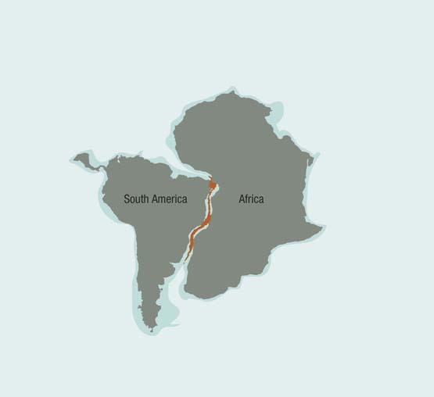 | Biogeographical – this evidence looks at how continental drift directly affects the location of organisms and provides an explanation for the geographical isolation of species that eventually results in speciation – divergent evolution. | Answers will vary. Examples include:  Marsupials in Australia and South America.  Similar lungfish are found in South America, South Africa and Australia.
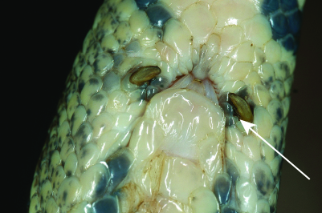 | Vestigial organs – the structures found in organisms that have no present-day function. They provide evidence of an ancestral heritage where these structures once performed other tasks. | Answers will vary. Examples include:  Molar teeth in humans.  The wings of flightless birds such as the cassowary.
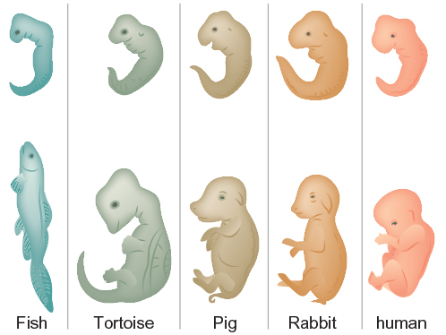 | Analysing embryos – similarities between the early embryos of different species are explained by inferring that these organisms all had a common ancestry with common genes. | Answers will vary. Examples include:  Gill-like structures in early human embryos.  Teeth development in early whale embryos.
4 List THREE vestigial structures that are found in the human body.
Answers will vary. Examples include: the muscles of the ear, coccyx/tailbone, wisdom teeth.
5 A student wrote the following statements regarding evidence for evolution. Determine whether each statement is true or false. For each false statement, write the correct description underneath it.
Description | True or False?
At one point in time, all the land masses were joined as the supercontinent Gondwana.  Correct statement: At one point in time, all the land masses were joined as the supercontinent Pangea. | False
Australia and Antarctica were once joined about 65 million years ago. | True
The early embryo of a horse first develops five finger-like digits that are then modified into a hoof in later stages of embryo development. | True
The forelimbs of different birds, whales and bats are examples of vestigial structures.  Correct statement: The forelimbs of different birds, whales and bats are examples of homologous structures. | False

Extend your understanding
6 Goosebumps are designed to raise the hairs on our skin to trap a warm layer of air and therefore reduce heat loss. Suggest why goosebumps are considered a vestigial feature in humans.
Because humans have much less hair than other mammals, the few raised hairs do not trap a warm layer of air as it does in other animals. Goosebumps no longer function to reduce heat loss and are therefore considered vestigial.
7 Suggest why vestigial organs are still present within an organism if they no longer serve a purpose.
A vestigial feature will not disappear completely unless there is a selection pressure against it. Having a vestigial feature is not a disadvantage, so the feature remains.

Student worksheet answers

2.6 DNA and proteins provide chemical evidence for evolution
Pages 56–57

Chemical evidence for evolution
1 What is the process that occurs during protein synthesis whereby amino acids are joined together to form proteins?
Translation
2 Describe the difference between an amino acid, a polypeptide chain and a protein.
There are 20 different amino acids that are the building blocks of proteins. They are joined together in a specific order to form a polypeptide chain. One or more polypeptide chains are modified, folded and joined to other polypeptides to form a functional protein.
3 Haemoglobin is a protein made up of four polypeptides that transports oxygen around the body. One of these polypeptides has 147 amino acids in vertebrates. The table shows the number of different amino acids in the haemoglobin polypeptide in different vertebrates when compared with human haemoglobin.
Vertebrate | Number of different amino acids
Gorilla | 1
Chicken | 45
Frog | 67
Mouse | 27
Dog | 32
a Order the vertebrates based on how closely related they are to humans based on the amino acid sequence of one haemoglobin polypeptide.
human, gorilla, mouse, dog, chicken, frog
b Does this support the hypothesis that humans are more closely related to primates than other vertebrates? Justify your answer.
Yes. There is only one amino acid difference between the sequence of gorillas and humans, which infers they diverged from a common ancestor relatively recently compared with the other vertebrates.
c What might have caused the change in the single amino acid change between gorillas and humans?
A mutation
d Although there is only one amino acid difference between gorillas and humans, there may be many more differences in the DNA sequence of the gorilla haemoglobin gene. Suggest a reason for this.
A codon, consisting of a sequence of three nucleotides, codes for each amino acid. We know there is at least one change in the DNA sequence, however, there may also be others because more than one codon codes for some amino acids. For example, the codons GGA, GGU, GGG, GGC all code for the amino acid glycine.

Extend your understanding
4 In the space below, sketch a basic phylogenetic tree regarding haemoglobin based on the information provided in the table in question 3.
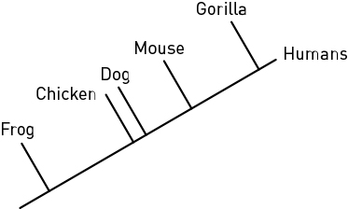
5 What conclusions can you make about species that have significant differences in their DNA sequences?
A long time has passed for the many differences in the DNA sequences to accumulate. Species with significant differences are less related than species with fewer differences. These species diverged from a common ancestor a very long time ago.

Student worksheet answers

2.7 Humans artificially select traits
Pages 58–59

Artificial selection
1 Write definitions for the following terms.
Term | Definition
Binary fission | Asexual reproduction in bacteria where DNA replication occurs and the cell splits into two.
Artificial selection | Humans breed organisms with desirable traits, increasing the chance of the trait occurring in the next generation.
Subspecies | Subdivision of a species that has different characteristics yet can still interbreed; for example, different breeds of dog.
Domesticated | No longer wild due to being breed over many generations to produce a desirable characteristic such as tameness.
2 Fill in the blanks.
Bacterial species can pass on antibiotic resistance to another bacterial species by a process known as horizontal transfer. This is where the antibiotic resistance gene is transferred from one bacterium to another. Because the bacterial cell divides by binary fission, every bacterium produced also has the gene and the species evolves rapidly.
3 For each organism below, identify the desirable trait that has been selected for and suggest a reason the trait was selected.
Organism | Desired trait | Reason for trait being selected
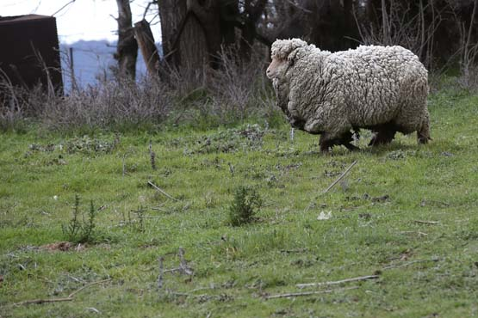 | Wool growth all year round | To produce wool as a resource for other items; for example, to make clothing.
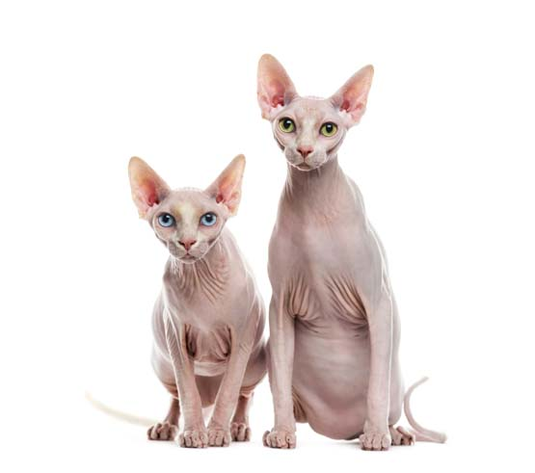 | Lack of fur | For people with allergies – less shedding of fur.
4 Wild fowls lay up to 30 eggs per year compared with barn chickens that can lay up to 300 eggs per year. Barn chickens have been selectively bred from wild fowls.
a Suggest ONE advantage and ONE disadvantage that could come from the selective breeding of chickens.
Answers will vary. Examples of an advantage include: increased supply of eggs for human consumption. Examples of a disadvantage include: shorter life expectancy of chickens, reduced calcium leads to weak bones – chickens would not survive in the wild.
b Outline the process a breeder could have used to selectively breed chickens that lay many eggs.
Select wild fowl hens that lay greater numbers of eggs. Breed these individuals with males that produce hens that lay increased numbers of eggs. Repeat over multiple generations, each time selecting to breed the offspring that lay the greatest number of eggs.

Extend your understanding
5 Using the following word list (plus any of your own words), create a Venn diagram in the space below to compare and contrast the processes of natural selection, genetic manipulation and artificial selection.
Word list: Human interference, recombinant DNA, mutation, gene transfer, evolution, Galapagos finches, antibiotic resistance, selection pressure, insulin production, transgenic, MRSA bacteria
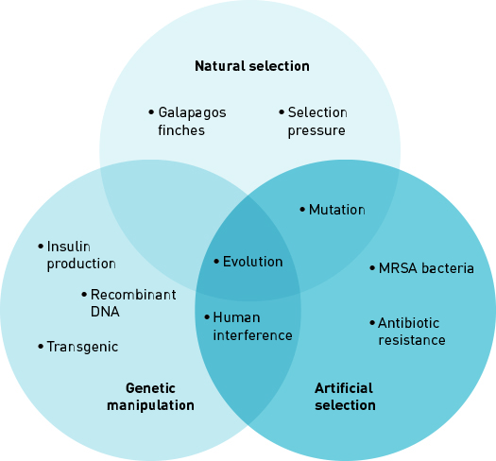
Student worksheet answers

2.8 Natural selection affects the frequency of alleles
Pages 60–61

Changes in alleles frequencies
1 What is the cause of sickle cell anaemia?
A mutation of the gene that codes for haemoglobin
2 What is the pattern of inheritance of the disease sickle cell anaemia?
Autosomal recessive
3 Fill in the blanks.
A single base change to the nucleotide triplet sequence from CTC to CAC within the haemoglobin gene results in the amino acid glutamic acid (GLU) being substituted with valine (VAL). This results in a mutated protein where the haemoglobin molecules are shaped like sickles/crescents and clump together.
4 Label and match the normal and mutated haemoglobin proteins to the normal and sickle cell red blood cells they produce.

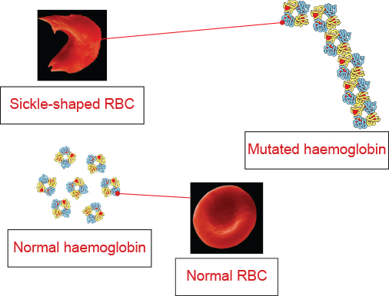
6 The following diagram shows the regions around the world with increased frequency of the sickle cell allele.
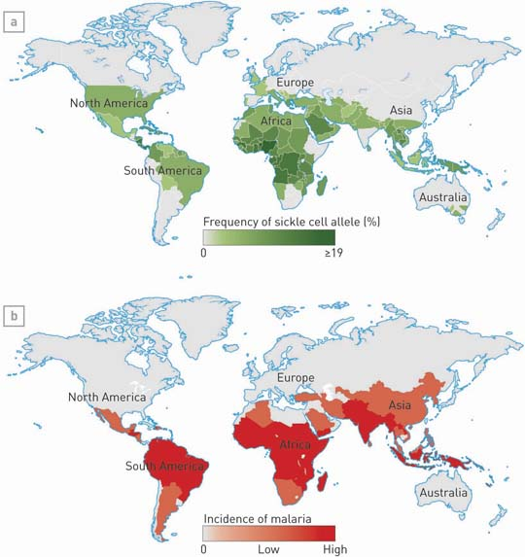
a Identify the selection pressure that results in an increase in the sickle cell allele in these regions.
Malaria
b What benefit does this disadvantageous mutation have to individuals in these regions?
They are protected from contracting malaria
c Explain why heterozygous individuals have an increased chance of survival compared with homozygous dominant and homozygous recessive individuals in these regions.
Heterozygous individuals are carriers – they have one normal allele and one sickle cell allele. They are both protected from contracting malaria and also do not have sickle cell anaemia. Homozygous dominant individuals can contract malaria, while homozygous recessive individuals have sickle cell anaemia.

Extend your understanding
7 Outline how the process of natural selection has led to an increase in the sickle cell allele over time in malaria-prone regions.
A genetic mutation in the haemoglobin allele gives an individual a selective advantage against malaria. Individuals without the mutation may die from malaria, and other individuals with two mutated alleles may not survive to reproduce as they die from sickle cell aneamia. Individuals with one mutated allele have greater fitness as they are both protected from contracting malaria and do not die from sickle cell anaemia. These individuals reach reproductive age, reproduce, and pass on the mutated allele to their offspring, therefore maintaining it within the population. Over time there is an increase in the frequency of the sickle cell allele in malaria-prone regions. In regions where malaria is not present, the mutated allele is not advantageous, therefore it is not maintained within the population because carriers do not have a survival advantage over homozygous dominant individuals.

